

Time: 50 minutes

Marks: / 46 marks

11 Essentials Unit 2 Test

Calculator Assumed
Allowed: 1 page double sided notes, Ruler

Name:

MULTIPLE CHOICE [7 marks]

1 The ratio of shaded parts to unshaded parts in the picture below is:

A 7 : 8 B 7 : 15

C 8 : 7 D 8 : 15

E 15 : 7

2 The ratio of total parts to shaded parts in the picture above is:

A 7 : 8 B 7 : 15 C 8 : 7

D 8 : 15 E 15 : 7

3 Which of the following is not equivalent to 8 : 12?

A 2 : 3 B 6 : 8 C 4 : 6

D 10 : 15 E 16 : 24

4 Holly was 108 cm tall when she turned 5 years old, and 162 cm when she turned
14 years old. Her average rate of growth is:

A 5 cm/year B 6 cm/year C 7 cm/year

D 8 cm/year E 9 cm/year

5 Maria can touch type 150 words in 3 minutes. How many words can she type in 7 minutes?

A 200 words B 250 words C 300 words

D 350 words E 400 words

6 Half an hour, converted to seconds, is:

A 36 seconds B 180 seconds C 360 seconds

D 1800 seconds E 3600 seconds

7 Written in 24-hour time, 5:45 pm is:

A 1345 B 1745 C 0545

D 1545 E 1945

SHORT ANSWER [39 marks]

Question 1 [2 marks]

Complete this two way table:

 | YES | NO | TOTAL
FEMALES | 14 | 26
MALES |  | 13
TOTAL |  |  | 100

Question 2 [5 marks]

This graph shows the stopping distances for cars on different surfaces.
a) Estimate the stopping distances for cars travelling in the following conditions.

i) snow at 60 km/h

ii) gravel at 110 km/h

b) What are the three possible road conditions for a stopping distance of 120 metres?

c) Approximately how much further does it take to stop on ice than a dry road when you are travelling at 80 km/h?

d) Approximately how much further does it take to stop from 110 km/h than at 60 km/h on a wet road?

Question 3 [1, 1 = 2 marks]

When there was a cyclone in Queensland, the price of bananas went up. They cost $48.60 for 9 kilograms.

- What is the price per kilogram?

- How much would it cost to buy 4 kilograms?

Question 4 [5 marks]
Milly entered the shotput at an athletics carnival. Her 14 distances are shown below (in cm):

415 412 407 413 421 405 419 420 409 405 420 404 417

Arabella has also entered the shotput. She recorded the following distances (in cm):

406 414 409 413 419 414 403 423 412 409 415 426 419

Draw a back-to-back stem-and-leaf plot for their distances. Who is better at shotput?, Explain why.

Question 5 [2, 1 = 3 marks]

The ratio of boys to girls in Year 11 is 5 : 6. There are 72 girls in Year 11.

- How many boys are there in Year 11?

- What is the total number of students in the year level?

Question 6 [5 marks]

Draw a boxplot for the set of data below:

13 22 13 30 15 17 10 22 16 35 7

Question 7 [2, 1 = 3 marks]
The scale is 1 : 1000. Calculate the real life-lengths of each feature on the map:
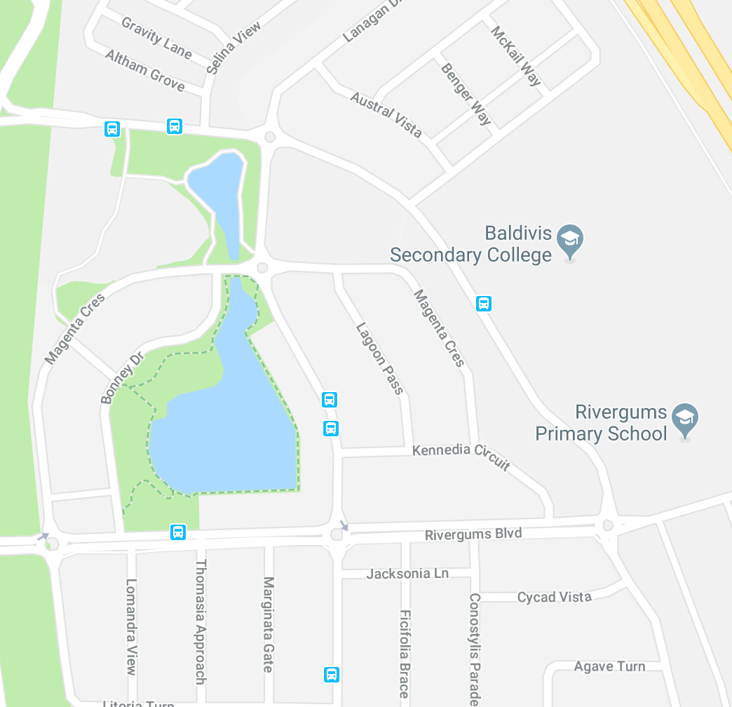

- The width of the lake

- If Tommy walks at a speed of 5m per minute, how long did it take him to walk to school?

Question 8 [8 marks]

Answer the following percentage questions, showing all working:

- What percentage of $48 is $3?

- At the start of 2015, you earned $350 per week in your job. If you first got a 4% pay rise and later got a 3% pay rise, how much do you now earn each week?

- A plumber’s quote is $350 before GST. What is the total amount you will have to pay, including the 10% GST?

- If $4500 is invested for two and a half years and it earns $528.75 interest, what is the interest rate per annum?

Question 9 [6 marks]

Daniel has moved out of home to live in a unit. He needs to be at work by 8:30am and has to catch a bus to a station and then a train. His walk from home to the bus stop takes 2 minutes. The bus trip takes 15 minutes and buses leave every 15 minutes from 6:00 am. The train trip takes 10 minutes and trains leave every 20 minutes from 6:05am. Daniel’s workplace is a 5 minute walk from the station. What is the latest time Daniel can leave home and still get to work on time?

